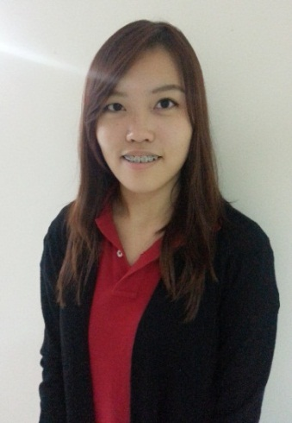**SERENE CHOO**

Address: 6, Jalan PUJ 7/12, Taman Puncak Jalil, 43300 Seri Kembangan, Selangor, Malaysia.

Tel: +60173148708

Email: [yinxuan91@hotmail.my](mailto:yinxuan91@hotmail.my)

NRIC: 911109-14-5834

**Profile**

- Processes good knowledge of methods in monitoring and analyzing the quality of products.

- Well-developed skills in Research and Development of products and preparation of samples to

customers.

- Trained in Food GMP, HACCP, Halal, and Health Supplement GMP.

- Certified Internal Auditor who has participated in External Audit and Mock Recall Program.

- Currently associated with Furley Biosystem S/B as a Quality Assurance Application Support.

- Self-motivated, hands on individual who can work independently or in a team.

- Has good analytical, problem solving and organizational abilities.

- Good sensory skills.

- Fluency in English, Mandarin, Malay and Cantonese.

**Skill Highlights**

* **Product Analysis**
* Conducted chemical and physical testing of raw and finished products and verified final released of finished products.
* Preparation of application samples for stability testing and evaluation.
* **Product Development**
* Involved in new products development and existing products improvement in the areas of formulation, sensory test, and product trials.
* Performed specialized and accurate application of ingredients for submission of samples to customers for sensory testing and evaluation.
* Generated product specifications to customer according to the prescribed procedures.
* Rendered supports to sales and marketing department on customer requests.
* Carried out sensory evaluation, ingredient applications and nutritional facts labeling.

* **Technically proficient in MS Word, Power Point, and Excel.**

**Career Accomplishment**

* Engaged in development of range of products, ensuring the growth of business and profitability of company.
* Successfully developed methods and procedures for new instrument by conducting various experiment with various experiment with different parameters.
* Maintained distinctive certifications such as HACCP and GMP systems and improved the standard operating procedures to ensure company practices comply with procedures.

**Professional Experience**

**Quality Assurance Application Support** Oct 2012 to Present

Furley Biosystem S/B – Puchong, Selangor, Malaysia.

* Enforced food safety management policies and procedures compliance with HACCP and GMP regulatory requirements.
* Conducted regular food safety audit of all production processes, including reviewing and evaluating adequacy of existing internal control systems and standard operating procedures.
* Performed root cause analysis when result is out of specification and follow up with the corrective and preventive action.
* Liaised and coordinated with suppliers or service providers for a better price or service for lab suppliers and equipment.
* Conducted checks and compilation of results on raw ingredients, in-process and final products through internal and external lab testing.
* Experienced on using pH meter, moisture analyzer, refractometer, or other basic lab equipment.
* Reason for leaving: Seek for a new challenge and good career opportunity.
* Availability to commence work: 2 months

**Education and Activities**

**Bachelor’s Degree of Biotechnology (Hons)** 2010- 2012

INTI International University – Nilai, Negeri Sembilan, Malaysia

- First Class Degree Holder, President’s List.

- Student Representative of Biochemistry Course, 2011.

- Participant of Famine 30 by World Vision Malaysia.

**Foundation of Science** 2009 - 2010

INTI International University – Nilai, Negeri Sembilan, Malaysia

- President’s List.